Data Classification Using AI
A Python AI Project (Iris Dataset & K-Nearest Neighbors)
Developed by Maria as part of the DecodeLabs Internship

Project Information
Project Title | Data Classification Using AI
Developed By | Maria
Language | Python 3
Project Type | AI / Supervised Learning (Classification)
Algorithm Used | K-Nearest Neighbors (KNN)
Dataset | Iris Dataset (150 samples, 3 classes, 4 features)
Developed For | DecodeLabs Internship
Project File | project2.py

Overview
This project builds a basic classification model using Supervised Learning. Unlike rule-based logic, this model is not told fixed answers — it is shown labelled examples (the Iris flower dataset) and learns to recognize patterns on its own. It then uses those learned patterns to classify new, unseen flowers into one of three species. This project forms the foundation for understanding how real-world AI systems are trained, tested, and validated.
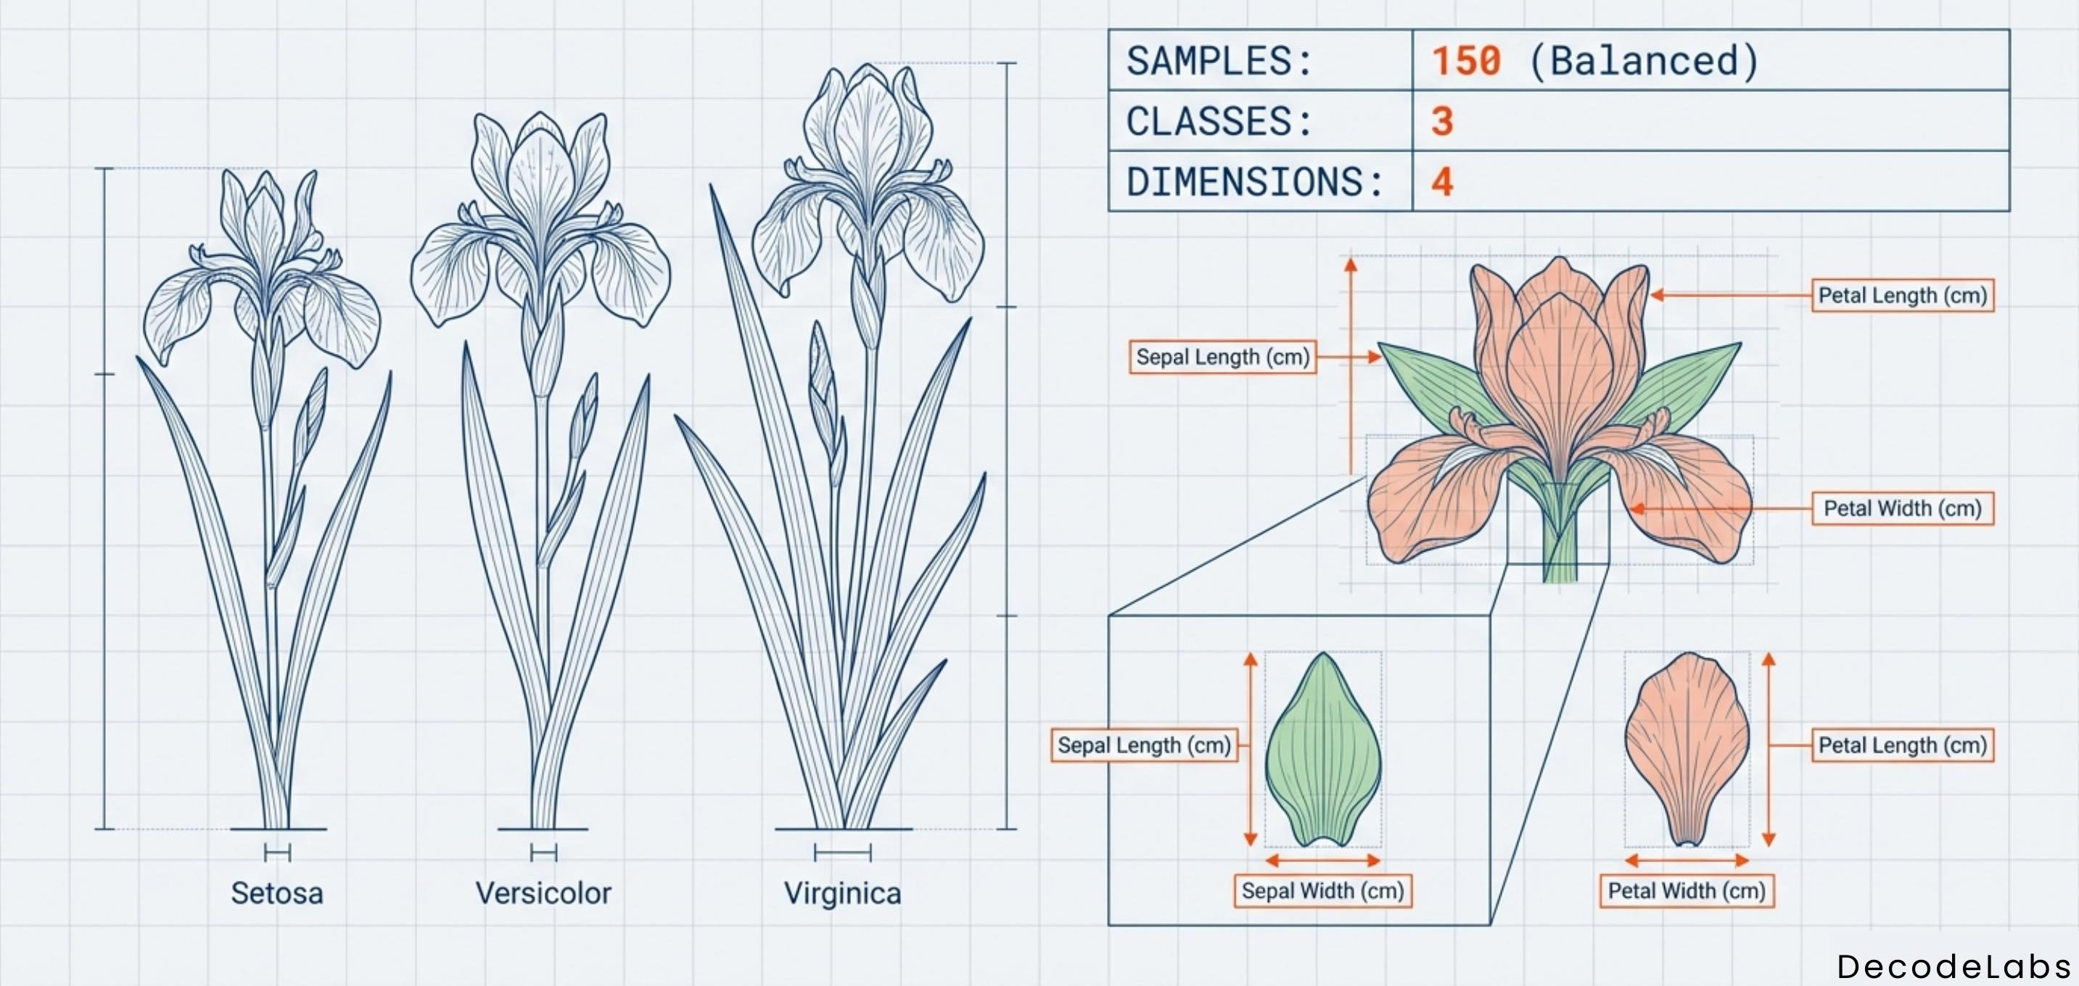
Fig. 1 — The Iris benchmark: 150 samples, 3 species, 4 measured features per flower.

How It Works
- The model uses the Iris dataset: 150 flower samples, each described by 4 measurements (sepal length, sepal width, petal length, petal width) and labelled with one of 3 species (Setosa, Versicolor, Virginica).
- The dataset is split into a training set (80%) and a testing set (20%), so the model can be evaluated on data it has never seen before.
- The features are scaled using StandardScaler so that no single measurement unfairly dominates the distance calculation.
- A K-Nearest Neighbors (KNN) classifier is trained on the training set. KNN works on the proximity principle: a new flower is classified by looking at its 5 closest neighbors and taking a majority vote of their species.
- The trained model predicts species for the unseen test set.
- The predictions are compared against the true labels using a confusion matrix and classification report to measure real performance, not just raw accuracy.

Key Concepts Used
- Supervised Learning — learning from labelled historical data instead of hardcoded rules.
- Train-Test Split — separating data to fairly validate the model on unseen samples.
- Feature Scaling (StandardScaler) — normalizing data so all features contribute equally.
- K-Nearest Neighbors (KNN) — a distance-based classification algorithm.
- Model Evaluation — accuracy score, confusion matrix, precision, recall, and F1 score.
- scikit-learn workflow — instantiate the model, fit() it on training data, then predict() on test data.

Source Code
Below is the complete Python source code for the classifier:
# 1. Load data
from sklearn.datasets import load_iris
from sklearn.model_selection import train_test_split
from sklearn.preprocessing import StandardScaler
from sklearn.neighbors import KNeighborsClassifier
from sklearn.metrics import accuracy_score, confusion_matrix, classification_report

data = load_iris()
X, y = data.data, data.target # X = measurements, y = species

# 2. Split BEFORE scaling (avoids data leakage)
X_train, X_test, y_train, y_test = train_test_split(
X, y, test_size=0.2, random_state=42
)

# 3. Scale the features
scaler = StandardScaler()
X_train = scaler.fit_transform(X_train)
X_test = scaler.transform(X_test)

# 4. Train the model
model = KNeighborsClassifier(n_neighbors=5)
model.fit(X_train, y_train)

# 5. Predict on unseen test data
predictions = model.predict(X_test)

# 6. Evaluate the results
print("Accuracy:", accuracy_score(y_test, predictions))
print(confusion_matrix(y_test, predictions))
print(classification_report(y_test, predictions))

Output Validation
On the Iris dataset, this model typically achieves 95–100% accuracy. However, accuracy alone can be misleading on imbalanced data, so the confusion matrix and classification report are used to check that all three species are being classified correctly — not just the easiest ones.

Possible Future Improvements
- Experiment with different values of K (e.g. 3, 7, 9) to find the optimal balance between overfitting and underfitting.
- Compare KNN against other classification algorithms such as Decision Trees, Logistic Regression, or Support Vector Machines.
- Test the trained model on completely new, real-world flower measurements outside the original dataset.
- Visualize the decision boundaries and confusion matrix as charts for easier interpretation.
- Extend the pipeline from tabular data toward image-based classification (Computer Vision) using Deep Learning / CNNs.
Prepared for the DecodeLabs Internship Program

